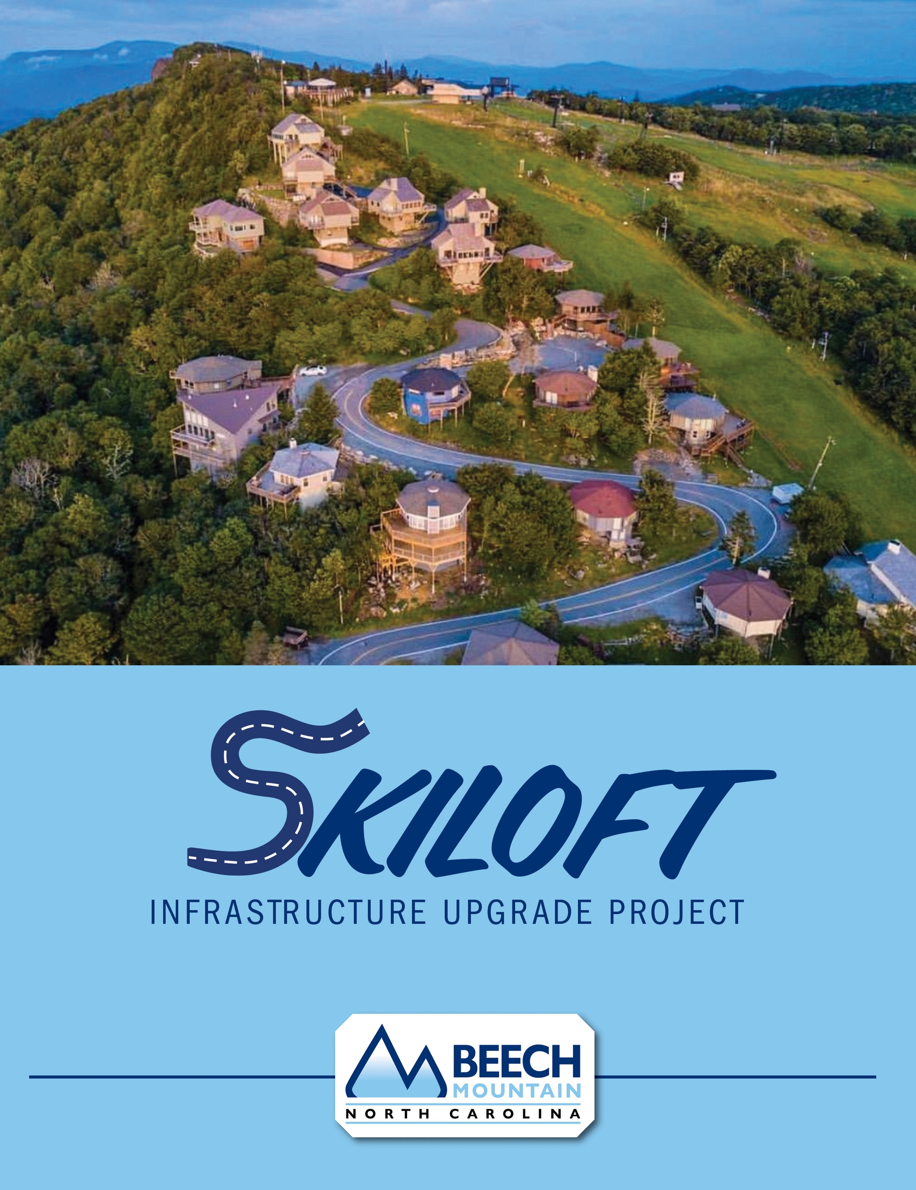

PROJECT SUMMARY

The water and sewer system currently serving the homes on Skiloft Road has reached a breaking point. We can no longer assure confidence in the system’s integrity. Over the last couple of years, countless small repairs to water and sewer lines have been made in the Skiloft neighborhood. This has become a serious concern for reliable and safe water services. It is compounded by other issues including stormwater management, crumbling pavement and poor traffic flow. The Town has received a grant from the State of North Carolina to make a full water and sewer system upgrade. This grant will fully fund all water system repairs to ensure continued safe and reliable service to the Skiloft community. There is an issue of time required for the funds to be used and we must take this opportunity now.
There are other utilities serving Skiloft as well. Mountain Electric provides electricity, and Skyline/Skybest provides telephone and internet. Charter Communications provides internet and cable television services. All these service providers have indicated to the town that their infrastructure has significantly passed its service life and all have experienced many recent failures, raising concerns about continued reliable service.
As a result, the Town has reached agreement with these additional utilities and will be providing support and partnership to allow for full replacement of these utilities along with the water and sewer services. The final product will be a fully upgraded set of infrastructure, serving Skiloft residents with the most recent technologies to carry into the future.
This is a major undertaking due to the topography of Skiloft Road. It is compounded by the fact the Skiloft has no outlet. All these utilities are buried in the roadway. Each has their own requirements for installation and the result is that most of the entire roadway must be excavated to achieve replacement. With the complete deconstruction and reconstruction process of the roadway, it is also the perfect opportunity to bring improvements to the drainage system to keep water and snow off the roadway as much as we can possibly achieve. Other minor changes will be necessary to ensure proper road width, slope, and removal of owner constructed obstructions place within the right of way to provide for infrastructure placement and safe driving conditions.

PROJECT SUMMARY

As a direct result of the large scope of work, the roadway will be closed to any access beginning April 1st, 2024, continuing through October 1st, 2024. During this time, all utility services will be unavailable as the old piping and wiring are removed and newly installed. Preliminary work around the area is expected to begin in the summer of 2023 and finalization in spring of 2025. The pre and post times will lightly affect movement with no continuing road closures or service outages.
The final result will be a fully upgraded system of Water and Sewer services, electrical and other utility services, vastly improved stormwater control and a new enhanced paved surface. We ask for each owner to partner with the town in allowing this to become a reality and bring value and longevity to each property.
A partnership agreement for this project will be provided to each owner and the Town will need every owner to join with us to make this project move forward. There will be no cost to any property owner for this project's work, and additional benefits will be provided to each owner once the project is accepted by the Skiloft community.

FREQUENTLY ASKED QUESTIONS

Why is a project beginning on Skiloft Road?
The existing utility services need upgrades. All utility services including Water, Sewer, Power, Internet, and Cable have experienced physical failures in the last few years and have reached their service life abilities. Also, there is a great need to improve roadway drainage to better control rainfall and storm runoff. The pavement surface needs to be re-paved.
How will this affect me as a property owner?
For an estimated 2 years, the roadway and area will be in construction phase. There will be workers performing tasks, materials being stored and prepared, markings flags and measurements will be taken and placed. During a period of the construction the roadway will be closed for an estimated 180-day window to complete the large part of the work due to the road being having no outlet.

As a part of this work, the road will be reconstructed to result in the best condition for public safety and storm drainage as we can make possible with the landscape. We have identified several cases where the existing retaining walls, stairways, and other owner created obstacles are withing the Town road right of way. As a part of this project, these encroachments will be relocated or reconstructed to be outside of the roadway.
When will this work begin?
Current expectations are that preliminary works will begin in the summer of 2023. It will continue with full access to the properties until April 1st of 2024. At that time Skiloft Rd. will be closed to any access for a period of 180 days, with the expectation that return to the properties will be available by Oct. 1, 2024.

FREQUENTLY ASKED QUESTIONS

Why must the road be closed, and access denied?
All the utilities are in the roadway which then makes individual connections to each home. The physical placement of these pipes, wires, and cables must be excavated in the roadway and will result in the entirety of the roadway being impassable by vehicle. The entire area will be a construction work zone with large equipment, swinging pipes and workers moving constantly to complete the upgrades in an efficient manner resulting in an unsafe space for public access. Also, during this time there will be no water, sewer, electricity, or internet functional to the homes as all old lines and wires will be removed and replaced with new infrastructure.
Will any action be required by each homeowner?
The Town is asking that all homeowners agree to this project. We will request that a document of acceptance be signed by each owner formalizing this agreement. ALL owners must agree and sign the agreement documents for this project to move forward into an actionable project. After all owners have signed and returned the agreement, the Town will provide $1000 in compensation for each homeowner. Without 100% agreement of all owners, THIS PROJECT WILL NOT MOVE FORWARD.
What will this cost me?
Once full agreement for all owners has been attained and the project has begun, there will be no cost from the Town to any owner. All upgrades and any issues of right of way encroachment will be funded by the Town. Further, beginning April 1st, 2024, when the roadway will be inaccessible, the town will stop utility charges to each account. This includes all charges for Water, Sewer, and Sanitation. These charges will resume once access to the properties has been formally restored.
Will I be able to check on my property while the road is closed?
The Town will work with the Contractor to provide periodic opportunities for homeowners to check on their properties. While no drive-up access will be possible, we are working with the contractor to identify brief periods when walking access will be permitted.

FREQUENTLY ASKED QUESTIONS

How can I keep updated on the progress? Who do I contact?
Send a request to kgavenus@townofbeechmountain.com to be added to the email list for weekly updates. Email recipients will also receive a monthly summary of the Contractor’s Progress Report, and a monthly update will also be posted on the Town of Beech Mountain Facebook page.

For general questions during this project, feel free to contact:
Kate Gavenus
Director of Community and Economic Development
kgavenus@townofbeechmountain.com
828-387-2903

Questions about utilities, road work, etc., may be directed to:
Daniel Davis
Director of Utilities
bmus@townofbeechmountain.com
828-387-9282

