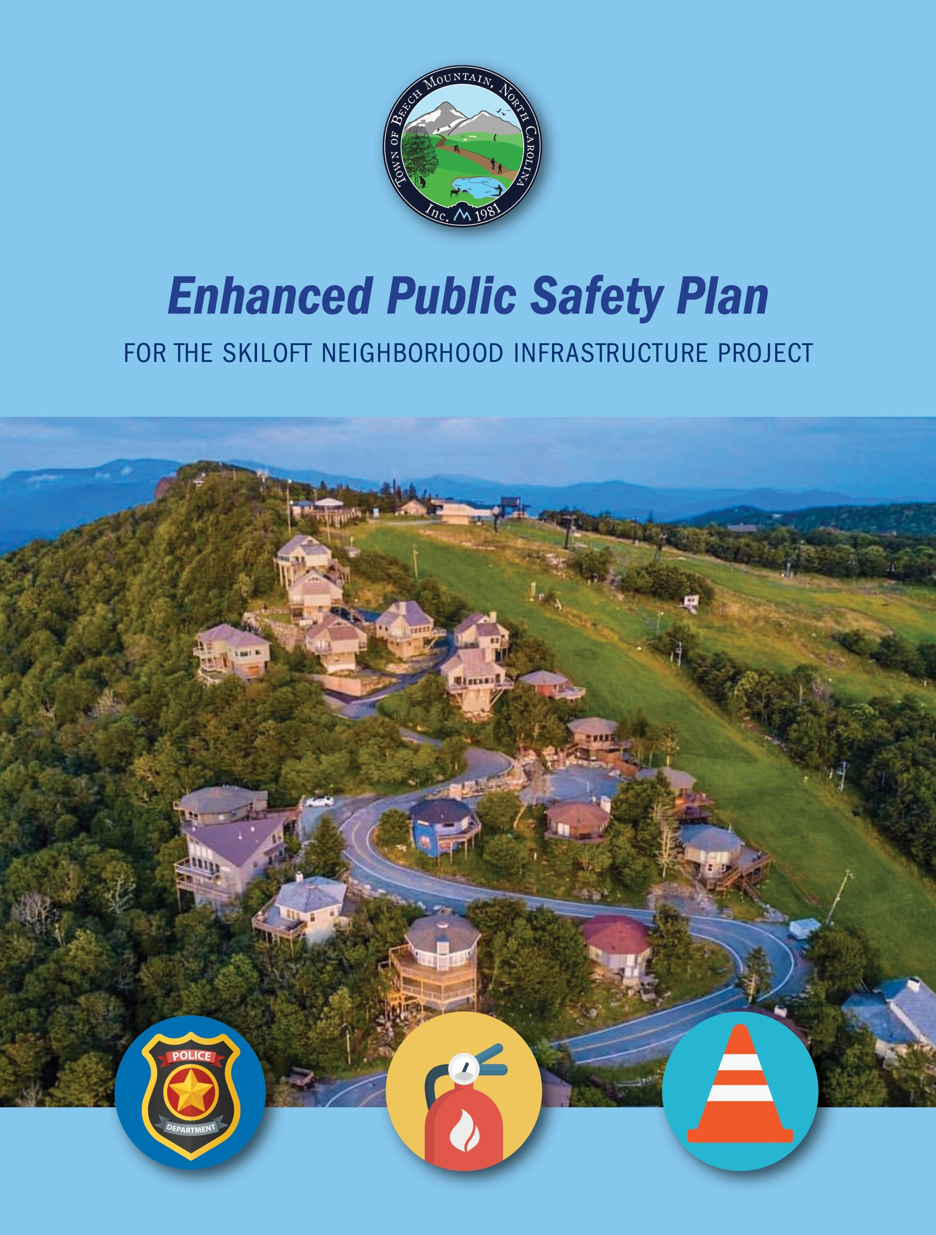
A
APRIL 2023

Background:
Beech Mountain was developed as a resort community in the late 1960’s and 1970’s. Skiloft Road was built alongside a ski slope and paved in the late 1970’s through funds contributed by homeowners.
Since the late 1970’s, many additional houses have been built in the Skiloft neighborhood. The water and sewer lines are now over 50 years old, and in need of replacement. These are located under the pavement, which is also in need of repair. Mountain Electric Cooperative has informed the town that their infrastructure which feeds the neighborhood is also in need of replacement, and the phone and cable service providers have indicated that they need to replace their service lines as well.
The Town of Beech Mountain has received grant funds from the state of North Carolina to address the most pressing water/sewer infrastructure improvement needs. Part of this grant is designated for the Skiloft neighborhood.
To provide timely and efficient upgrades and replacements for all the utilities, Skiloft Road will be closed from April 1, 2024 through September 30, 2024. Water/sewer, electricity, cable, and phone service will be shut down during most of this time. All systems will be replaced and upgraded with the highest quality materials available, and the road will be re-paved, with new guttering and drainage added.
Purpose of the Safety Plan:
The Town of Beech Mountain recognizes the need for careful attention and monitoring from public safety personnel during the time of this project, to ensure that properties are secure and protected from fire, theft, vandalism, natural disasters, and other adverse events. Representatives of the Fire Department, Police Department and Community Development have met, and under advisement of professionals in the insurance industry, have developed enhancements to regular Town services which will take place during the time that the Skiloft Neighborhood Infrastructure Project is underway.
Skiloft Infrastructure Project Public Safety Plan
- The Beech Mountain Resort, which owns the land adjacent to the Skiloft neighborhood, has given permission for access over their property for public safety personnel for the duration of the project

- A temporary five-inch water line will be run from the town’s water tank at the top of ski slope, to provide optimal water supply for fire suppression

- In the event of a fire in close proximity, the Fire Department will conduct visual monitoring patrols of all structures in the Skiloft neighborhood until the fire has been fully suppressed

- The Police Department will utilize enhanced progressive patrols, using UTV’s and personnel on foot, during the entirety of the project
- A surveillance drone, piloted by a police officer, will be used regularly to view all properties in the neighborhood

- Multiple portal light towers will be placed strategically within the neighborhood, to provide nightly illumination and deter trespassing or theft

- Weekly walk-up and monthly drive-up access will be provided to homeowners for property checks and routine maintenance

- The town will work with homeowners on a case-by-case basis, should the need arise for significant home repairs on Skiloft properties during the project

For more information, contact:
Bob Pudney, Town Manager and Fire Chief 828-387-4236
rpudney@townofbeechmountain.com
Tim Barnett, Police Chief 828-387-2342
tbarnett@townofbeechmountain.com

